**Kocaeli University, Electronics and Telecommunications Engineering Department**

**Digital Communications Laboratory**

**Experiment 5: BFSK Modulation and Demodulation - Lab Report**

|  |
| --- |
| Name-Surname-Number: |
| Name-Surname-Number: |
| Name-Surname-Number: |

**SIMULINK PART - The table below is for verification only and filled by the lab instructor.**

|  |  |
| --- | --- |
| Understanding the existence of multiple carriers in BFSK (10 pts) |  |
| Understanding bandwidth and power consumption of BFSK (10 pts) |  |
| Understanding the Synchronous Demodulation of BFSK (10 pts) |  |
| Understanding the Asynchronous Demodulation of BFSK (10 pts) |  |

**STM32 PART - Section 1: Transmitting a Data Byte Using BFSK Modulation**

**Step 1:** Set the carrier frequencies and txData value as **it is given on the whiteboard**. Build STM32 code and flash the MCU then reset it, you don’t need to run MCU in debug mode.

**Step 2:** Connect NI Elvis II Scope CH0 to **Frame Sync Signal (D8 on Nucleo-64 or PA9 on Discovery)**.

**Step 3:** Connect NI Elvis II Scope CH1 to **BFSK Modulation output** **(A2 on Nucleo-64 or PA4 on Discovery).**

**Step 4:** Adjust the Scope divisions (1V/Div, 500µS/Div). Set Scope CH0 vertical position at -3V. Set your Scope “Trigger Type” to “Edge”, “Level” to “1V” and Trigger “Source” to “Scope CH0”.

**Step 5:** Plot your Scope screen on the graph. (20 pts)

**Section 2: Exploring Frequency Spectrum of BFSK Modulation**

**Step 6:** Stop the Scope then Open NI Elvis II DSA. Adjust the DS parameters as listed in the table below:

|  |  |
| --- | --- |
| **Source Channel** | SCOPE CH1 |
| **Frequency Span** | 40000 |
| **Units** | Linear |

**Step 7:** Fill in the table below. (20 pts)

|  |  |
| --- | --- |
| Frequency of “1” Bit Carrier (kHz) |  |
| Frequency of “0” Bit Carrier (kHz) |  |
| Data rate (kbit/s) |  |
| Bandwidth (kHz) |  |

**Section 3: Converting BFSK Signal to BASK Signal**

**Step 8:** We can use an LPF to pass the “0” bit carrier while attenuating “1” bit carrier. Construct the LPF circuit below.

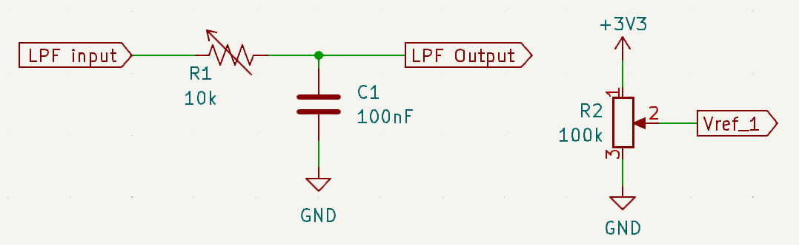

**Step 9:** Connect **BFSK Modulation output** to **LPF input**. Disconnect Scope CH1 from BFSK modulation output and connect it to **LPF output**.

**Step 10:** Adjust R1 value until bypassing the “1” bit carrier (it will not be bypassed entirely but keep its amplitude as minimum as possible). Write the resistance value in the table below. (5 pts)

|  |  |
| --- | --- |
| **R1 value (kΩ)** |  |

**Step 11:** Disconnect the Scope CH1 from LPF output. Connect LPF output to **COMP1 (comparator) input (+) pin** **(A1 on Nucleo-64 or PA1 on Discovery)**. Connect the variable voltage pin of the potentiometer **(Vref_1)** to **COMP1 input (-) pin (A0 on Nucleo-64 or PA0 on Discovery)**.

**Step 12:** Connect Scope CH1 to **COMP1** **output pin (D12 on Nucleo-64 or PA6 on Discovery)**. Adjust R2 value until getting the BASK signal. Write the resistance value in the table below. (5 pts)

|  |  |
| --- | --- |
| **R2 value (kΩ)** |  |

**Section 4: Demodulating BFSK Signal**

**Step 13:** We can use an **Envelope Detector** circuit to demodulate any amplitude modulated signal (including BASK). Construct the Envelope Detector circuit below (R3 is a 10kΩ potentiometer).

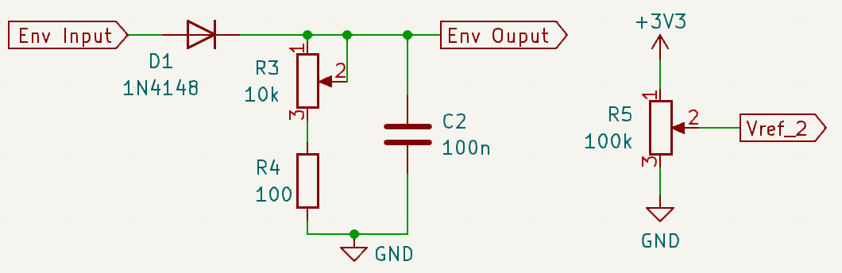

**Step 14:** Connect **COMP1 output** to **Env input**. Disconnect Scope CH1 from **COMP1 output** and connect it to **Env output**. Set R3 value to 0 Ω then increase it gradually until getting rid of ripple in **Env Output** (Check it by monitoring Scope CH1). Write the resistance value in the table below. (5 pts)

|  |  |
| --- | --- |
| **R3 value (kΩ)** |  |

**Step 15:** Build a voltage divider using a potentiometer (place it on a breadboard) and connect the variable voltage pin of the potentiometer **(Vref_2)** to **COMP2 input (-) pin (D1 on Nucleo-64 or PA2 on Discovery)**.

**Step 16:** Connect **Env Output** to **COMP2 input (+) pin (D0 on Nucleo-64 or PA3 on Discovery)**.

**Step 17:** Disconnect Scope CH1 from **Env Output** then connect it to **COMP2** **output pin (D11 on Nucleo-64 or PA7 on Discovery)**.

**Step 18:** Set R5 value to 0 Ω then increase it gradually until getting rid of ripple in **Env Output** (Check it by monitoring Scope CH1). Write the resistance value in the table below. (5 pts)

|  |  |
| --- | --- |
| **R5 value (kΩ)** |  |

**Section 5: Comments on BFSK Demodulation**

**Step 19:** Answer the question written on the whiteboard. (10 pts bonus)